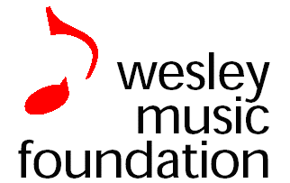
ACT ORGAN SCHOOL
Organ Scholarships 2020
APPLICATION FORM

WMC Application 191115
ABN 71 567 791 250
20-22 National Circuit, Forrest, ACT
Phone 02 6232 7248
wesleymc@musicwesleycanberra.org.au
www.wesleycanberra.org.au/music

All sections to be completed electronically and returned via email. Where not applicable, please insert “N/A”

Section 1 – Applicant Details
Surname: Click here to enter text. First Name: Click here to enter text.
Address: Address 1: Click here to enter text.
Address 2: Click here to enter text.
City: Click here to enter text.State: Choose an item. Postcode: Click here to enter text.

Phone: (H) Click here to enter text.
(M) Click here to enter text.
Email: Click here to enter text.
Date of Birth: Click here to enter text.

Parent permission has been given if applicant is under 18 ☐
If you are under 18yrs, please ask one of your parents to supply a short statement (email) saying that they support your application for a Scholarship

Section 2 – Musical Experience
Piano and other music teacher(s):

Exams undertaken and grades:

Summary of works played:

Any scholarships, awards, prizes or grants received:

Other relevant achievements:

Longer term musical goals and interests:

Current Academic degree, or school electives:

Estimate your sight-reading ability: Choose an item.

Names and contact details (phone numbers) for at least two referees:
- Click here to enter text.
- Click here to enter text.
- Click here to enter text.

We will not organise auditions until early 2020. Are you available for audition in the week beginning Monday, 3rd February 2020? Choose an item.
If you are not available, we will contact you to arrange a convenient time/day.

Todays date: Click here to enter a date.

Additional relevant information has been attached: ☐

Applications for scholarships on this form should be forwarded by email only to Liz McKenzie at lizm@music.wesleycanberra.org.au at any time up to 5pm on Friday 6th December 2019

